**Part 1**

Question 1





Question 2



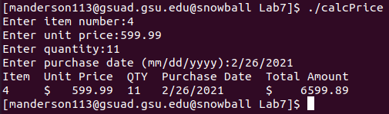

**Part 2**



